DESHBANDHU COLLEGE
UNIVERSITY OF DELHI
KALKAJI, NEW DELHI-110019

NOTICE II FOR PAYMENT OF COLLEGE ANNUAL FEES
ONLY FOR SECOND AND THIRD YEAR STUDENTS

Date: September 23, 2021

In continuation to the notice dated August 24, 2021 regarding payment of college Annual Fees for II and III year students.
All the students who have been promoted to II year & III year are hereby informed that the last date to pay the college annual fees through the College ERP portal has been extended up to September 30, 2021.
Link for the payment:
https://deshbandhucollege.in/OnlinePayment_DBU/Student_Login.aspx

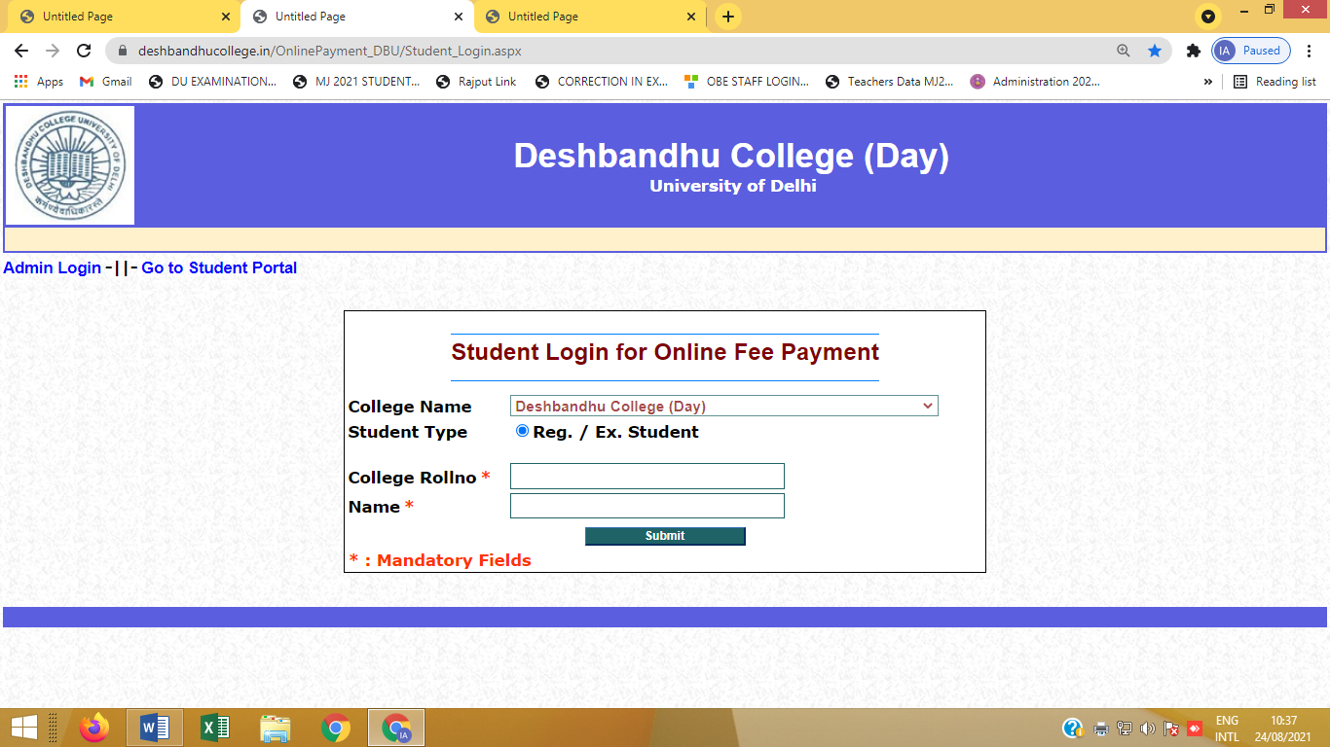
Procedure to pay the fees:
Step 1: Open the link given above
Step 2: Enter the details asked
Step 4: After this you will get options to pay college fees
Step 5: Take a snapshot of confirmation page and take a print out of fees receipt.
For any query mail on officeaccounts@db.du.ac.in

Principal

